Lab No. 11

Intel SIMD Technology

Task no 01:
Program:
#include <stdio.h>

int dot_product(short a[], short b[], int N)
{
int i, sum = 0;

// Loop unrolling by factor of 4
for(i = 0; i <= N - 4; i += 4)
{
sum += a[i] * b[i];
sum += a[i+1] * b[i+1];
sum += a[i+2] * b[i+2];
sum += a[i+3] * b[i+3];
}

// Handle remaining elements if N is not divisible by 4
for(; i < N; i++)
{
sum += a[i] * b[i];
}

return sum;
}

int main()
{
short a[1024], b[1024];
int i;

// Example initialization
for(i = 0; i < 1024; i++)
{
a[i] = i % 10;
b[i] = (i + 1) % 10;
}

int result = dot_product(a, b, 1024);
printf("Dot product = %d\n", result);

return 0;
}

Output:
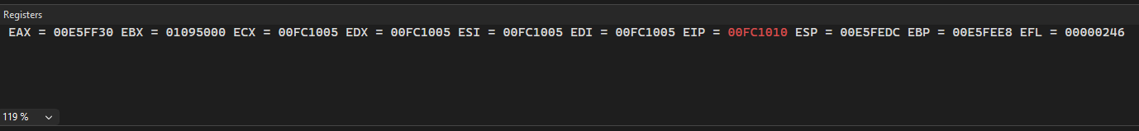
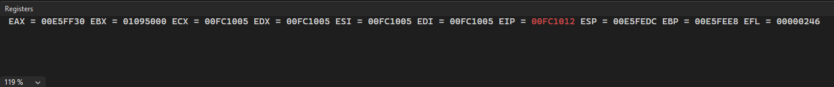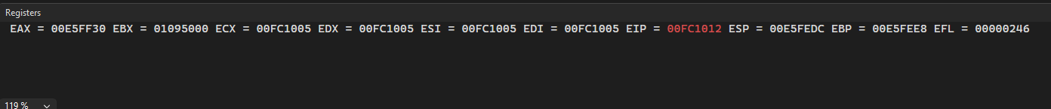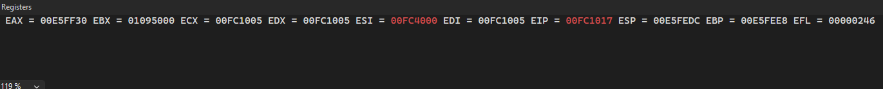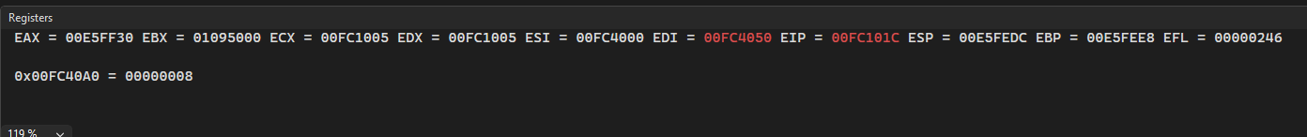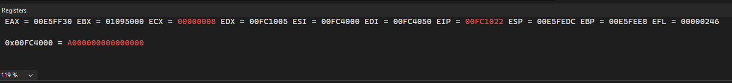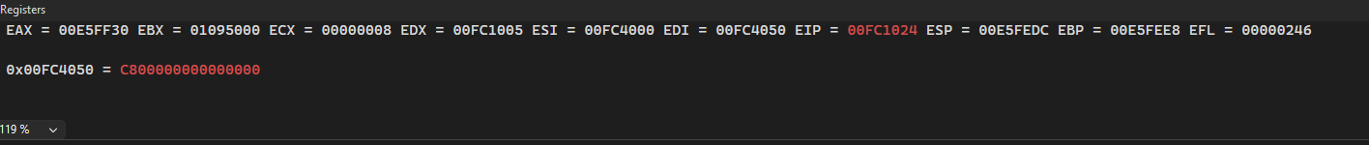
Task no 02:
Write the inline assembly code for the loop unrolled code using MMX instruction set. The inline assembly template will look like as follows;
Program:

#include <stdio.h>
#include <windows.h> // for __asm on MSVC

int dot_product(short a[], short b[], int N)
{
int sum = 0;

__asm {
// save context
pushad; // save all general purpose registers
pushfd; // save all flags

mov ecx, N // loop counter
xor eax, eax // clear accumulator
mov esi, a // pointer to array a
mov edi, b // pointer to array b

pxor mm0, mm0 // mm0 will hold partial sums

loop_start:
cmp ecx, 0
jle loop_end

// load 4 shorts from a and b
movq mm1, [esi] // load 4 x 16-bit from a
movq mm2, [edi] // load 4 x 16-bit from b

// multiply packed signed words and add adjacent pairs
pmaddwd mm1, mm2 // result: 2 x 32-bit sums

paddd mm0, mm1 // accumulate into mm0

add esi, 8 // advance pointer (4 shorts = 8 bytes)
add edi, 8
sub ecx, 4 // decrement counter by 4
jmp loop_start

loop_end:
// extract result from mm0
movq mm3, mm0
movd eax, mm3 // lower 32 bits
psrlq mm3, 32 // shift right to get upper 32 bits
movd edx, mm3 // upper 32 bits
add eax, edx // combine both

add sum, eax // store into sum

emms // clear MMX state

// restore context
popfd
popad
}

return sum;
}

int main()
{
short a[1024], b[1024];
int i;

// Example initialization
for(i = 0; i < 1024; i++)
{
a[i] = i % 10;
b[i] = (i + 1) % 10;
}

int result = dot_product(a, b, 1024);
printf("Dot product = %d\n", result);

return 0;
}

Output:
